Lagged cross-correlation: EURUSD and AUDUSD
Method 12 / daily log returns / K_max=10 / Alpari D1 full available history

Study setup
Logical pair: EURUSD , AUDUSD
Broker symbols: EURUSD_i , AUDUSD_i
Snapshot: 2026-11-03_majors_alpari_D1
Timeframe: D1
Matched return window: 1999-01-05 to 2026-11-02 (UTC bar dates)
Matched return count n: 7201
Dropped unfinished last bar dated 2026-11-03 UTC after a tick-volume check against the prior complete day.
Lag definition: rho_X->Y(k) = Corr(x_t, y_{t+k}) on matched D1 bars
K_max = 10; headline lag k = 1 (both directions)
Complete matched rows (Excel): EURUSD-AUDUSD_Lagged_D1.xlsx
Complete matched rows (HTML table): EURUSD-AUDUSD_Lagged_D1_data.html

Method carried forward
Lagged cross-correlation measures Pearson correlation between matched daily log returns of close, ln(close_t / close_t-1), after shifting one series forward by k bars on the matched panel. Quotes are not inverted. rho_{X->Y}(k) = Corr(x_t, y_{t+k}) with n_k = n - k. K_max = 10 is fixed before estimation. The headline is the pre-specified lag k = 1 in both directions. k = 0 is the same-bar side check. The lag inside 1..10 with the largest absolute rho is stored as a descriptive column only; it is not a selected result. This is a linear screen, not proof of forecast edge, economic cause, or a trading signal.

Results (headline k=1)
rho_EURUSD->AUDUSD(1): -0.042867 (n=7200)
95% Fisher interval EURUSD->AUDUSD: [-0.065901, -0.019788]
rho_AUDUSD->EURUSD(1): -0.009827 (n=7200)
95% Fisher interval AUDUSD->EURUSD: [-0.032919, 0.013275]
Same-bar rho(k=0): 0.556324
Largest |rho| among k=1..10 (descriptive only, not selected): EURUSD->AUDUSD k=4 rho=0.044494; AUDUSD->EURUSD k=9 rho=-0.043022

CCF table
k | rho_EURUSD_to_AUDUSD | n_EURUSD_to_AUDUSD | rho_AUDUSD_to_EURUSD | n_AUDUSD_to_EURUSD
0 | 0.55632387 | 7201 | 0.55632387 | 7201
1 | -0.04286721 | 7200 | -0.00982725 | 7200
2 | 0.01680499 | 7199 | -0.01743606 | 7199
3 | -0.00310007 | 7198 | -0.00527589 | 7198
4 | 0.04449395 | 7197 | 0.01627307 | 7197
5 | -0.01150655 | 7196 | 0.01538578 | 7196
6 | -0.01287837 | 7195 | -0.02669368 | 7195
7 | 0.00625074 | 7194 | 0.00056564 | 7194
8 | 0.0164435 | 7193 | 0.0153492 | 7193
9 | -0.00314589 | 7192 | -0.04302245 | 7192
10 | -0.01330079 | 7191 | 0.00698152 | 7191

Conclusion
At the pre-specified lag k=1 for EURUSD and AUDUSD, rho_{EURUSD->AUDUSD}(1) = -0.0429 (n=7200) and rho_{AUDUSD->EURUSD}(1) = -0.0098 (n=7200). Same-bar rho(k=0) = 0.5563. Largest |rho| among k=1..10 is descriptive only: EURUSD->AUDUSD at k=4 (0.0445); AUDUSD->EURUSD at k=9 (-0.0430). This is a linear screen, not forecast proof or a trading signal.

Charts
Daily closes

Daily log returns

CCF both directions k=0..10
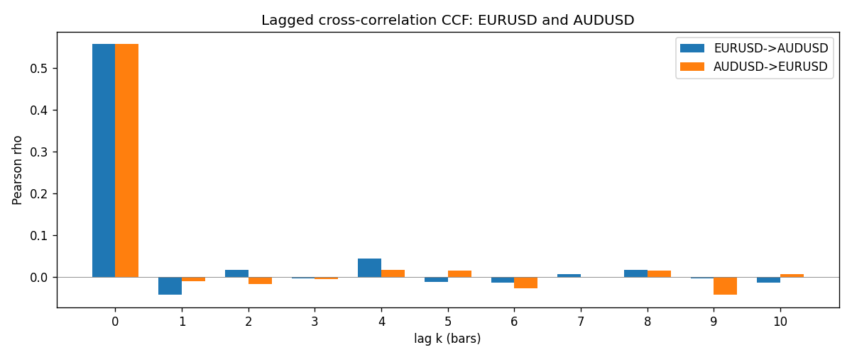

Data report
Every matched row is stored in the sibling Excel workbook named EURUSD-AUDUSD_Lagged_D1.xlsx (sheet matched_rows). The CCF sheet holds rho(k) for k=0..10. Embedding all rows as a Word table is impractical; the Word file holds column summaries and the first and last 15 rows.
Columns: time, EURUSD_open, AUDUSD_open, EURUSD_high, AUDUSD_high, EURUSD_low, AUDUSD_low, EURUSD_close, AUDUSD_close, EURUSD_tick_volume, AUDUSD_tick_volume, EURUSD_spread, AUDUSD_spread, EURUSD_real_volume, AUDUSD_real_volume, EURUSD_log_return, AUDUSD_log_return
Column summaries (matched calculation rows)
column | count | mean | std | min | 25% | 50% | 75% | max
EURUSD_open | 7201 | 1.1813268 | 0.15086382 | 0.8272 | 1.08608 | 1.16615 | 1.29393 | 1.5995
AUDUSD_open | 7201 | 0.75197127 | 0.13525779 | 0.4785 | 0.66105 | 0.73142 | 0.80912 | 1.10284
EURUSD_high | 7201 | 1.1864593 | 0.1514619 | 0.8326 | 1.0902 | 1.17128 | 1.29926 | 1.6038
AUDUSD_high | 7201 | 0.75602178 | 0.13581838 | 0.4878 | 0.6647 | 0.7349 | 0.81518 | 1.10795
EURUSD_low | 7201 | 1.1763142 | 0.15018707 | 0.8227 | 1.08202 | 1.16257 | 1.28834 | 1.5865
AUDUSD_low | 7201 | 0.74791431 | 0.13457219 | 0.4775 | 0.6577 | 0.72758 | 0.8042 | 1.0975
EURUSD_close | 7201 | 1.1813656 | 0.15083992 | 0.8267 | 1.08601 | 1.16617 | 1.29395 | 1.5997
AUDUSD_close | 7201 | 0.75202148 | 0.13524071 | 0.4786 | 0.6612 | 0.73175 | 0.80916 | 1.10169
EURUSD_tick_volume | 7201 | 103004.8 | 173409.64 | 469 | 9389 | 52708 | 99441 | 1471626
AUDUSD_tick_volume | 7201 | 77347.024 | 138135.9 | 109 | 5434 | 43320 | 71320 | 1234623
EURUSD_spread | 7201 | 19.396195 | 16.574381 | 0 | 8 | 12 | 30 | 50
AUDUSD_spread | 7201 | 30.819886 | 16.887485 | 0 | 13 | 30 | 50 | 50
EURUSD_real_volume | 7201 | 4.0238636e+10 | 1.6675367e+11 | 0 | 0 | 0 | 0 | 3.6149665e+12
AUDUSD_real_volume | 7201 | 5.2420906e+09 | 1.2538049e+11 | 0 | 0 | 0 | 0 | 3.811512e+12
EURUSD_log_return | 7201 | -7.54e-06 | 0.00580172 | -0.03123819 | -0.00324684 | 0 | 0.00325501 | 0.03433183
AUDUSD_log_return | 7201 | 2.459e-05 | 0.00754509 | -0.08602525 | -0.00385511 | 0.00028229 | 0.00415126 | 0.0806166
First 15 matched rows (selected columns)
time | EURUSD_close | AUDUSD_close | EURUSD_log_return | AUDUSD_log_return
1999-01-05 | 1.1758 | 0.6215 | -0.0048360507 | -0.00080418179
1999-01-06 | 1.1623 | 0.6289 | -0.011547966 | 0.011836351
1999-01-07 | 1.1712 | 0.6345 | 0.0076280636 | 0.0088650256
1999-01-08 | 1.1585 | 0.6347 | -0.010902799 | 0.00031515916
1999-01-11 | 1.1503 | 0.6393 | -0.007103287 | 0.0072213815
1999-01-12 | 1.1555 | 0.6362 | 0.0045103728 | -0.0048608485
1999-01-13 | 1.1681 | 0.6312 | 0.010845346 | -0.0078902098
1999-01-14 | 1.1681 | 0.6295 | 0 | -0.002696916
1999-01-15 | 1.1563 | 0.634 | -0.010153245 | 0.007123101
1999-01-18 | 1.1605 | 0.6346 | 0.0036256946 | 0.00094592471
1999-01-19 | 1.1603 | 0.6392 | -0.00017235436 | 0.0072225153
1999-01-20 | 1.1566 | 0.64 | -0.0031939256 | 0.0012507819
1999-01-21 | 1.1601 | 0.6405 | 0.0030215416 | 0.00078094498
1999-01-22 | 1.1587 | 0.6327 | -0.0012075213 | -0.012252745
1999-01-25 | 1.1552 | 0.6302 | -0.0030251979 | -0.0039591468
Last 15 matched rows (selected columns)
time | EURUSD_close | AUDUSD_close | EURUSD_log_return | AUDUSD_log_return
2026-10-13 | 1.11965 | 0.69821 | 0.0037402957 | 0.0035007712
2026-10-14 | 1.11545 | 0.69715 | -0.0037582255 | -0.0015193215
2026-10-15 | 1.12172 | 0.69191 | 0.0056053107 | -0.0075447063
2026-10-16 | 1.12371 | 0.69426 | 0.0017724895 | 0.0033906408
2026-10-19 | 1.12086 | 0.6978 | -0.0025394633 | 0.0050859986
2026-10-20 | 1.12354 | 0.70022 | 0.0023881672 | 0.0034620426
2026-10-21 | 1.12318 | 0.70275 | -0.00032046717 | 0.0036066384
2026-10-22 | 1.12139 | 0.70186 | -0.0015949606 | -0.0012672558
2026-10-23 | 1.11989 | 0.70353 | -0.001338521 | 0.0023765656
2026-10-26 | 1.11735 | 0.70128 | -0.0022706559 | -0.0032032829
2026-10-27 | 1.11272 | 0.70245 | -0.004152342 | 0.0016669876
2026-10-28 | 1.1152 | 0.70533 | 0.0022262927 | 0.0040915541
2026-10-29 | 1.11772 | 0.70245 | 0.0022571351 | -0.0040915541
2026-10-30 | 1.11644 | 0.70316 | -0.0011458446 | 0.0010102376
2026-11-02 | 1.11881 | 0.69971 | 0.002120569 | -0.0049184984

